TASK 2:

Code:

package day4;

import org.openqa.selenium.By;

import org.openqa.selenium.WebDriver;

import org.openqa.selenium.edge.*;

import org.openqa.selenium.JavascriptExecutor;

import org.openqa.selenium.edge.EdgeDriver;

import io.github.bonigarcia.wdm.WebDriverManager;

public class Task2 {

public static void main(String args[]) {

WebDriverManager.edgedriver().setup();

EdgeOptions co = new EdgeOptions();

co.addArguments("--remote-allow-origins=*");

WebDriver driver = new EdgeDriver(co);

driver.get("https://demo.opencart.com/index.php?route=account/register&language=en-gb");

driver.findElement(By.id("input-firstname")).sendKeys("Jishnu");

driver.findElement(By.id("input-lastname")).sendKeys("MS");

driver.findElement(By.id("input-email")).sendKeys("727721eucs050");

driver.findElement(By.id("input-password")).sendKeys("Kranto");

JavascriptExecutor js = (JavascriptExecutor) driver;

js.executeScript("window.scrollBy(0,600)","");

try

{

Thread.sleep(500);

}

catch(Exception e)

{

e.printStackTrace();

}

driver.findElement(By.id("input-newsletter-yes")).click();

}

}

Output:

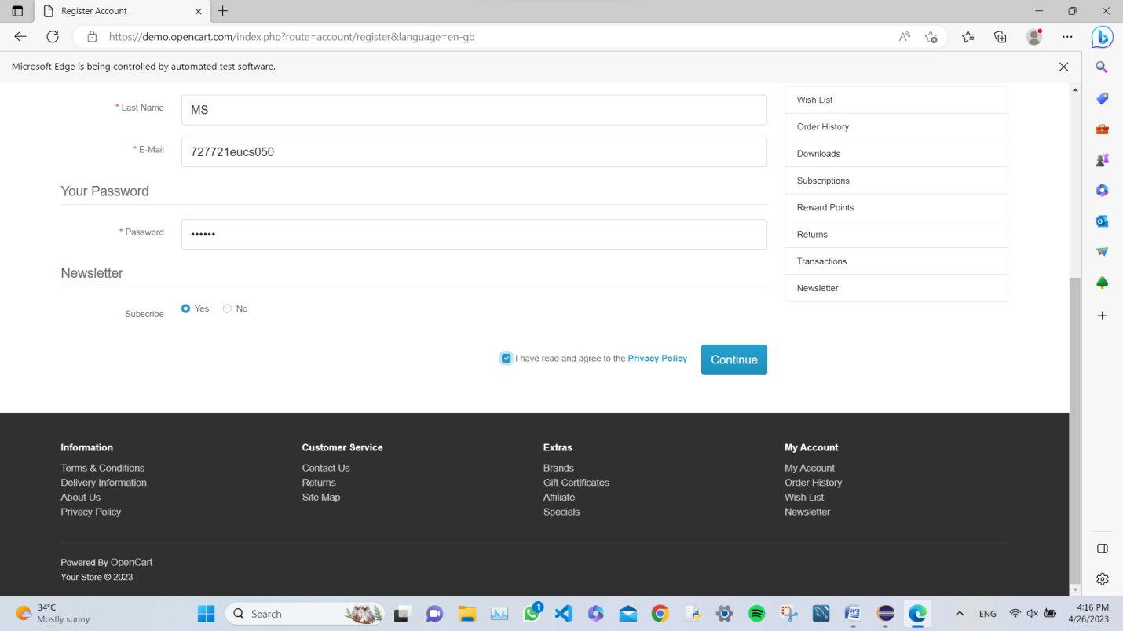

TASK 3:

CODE:

package day4;

import org.openqa.selenium.By;

import org.openqa.selenium.WebDriver;

import org.openqa.selenium.WebElement;

import org.openqa.selenium.edge.EdgeDriver;

import org.openqa.selenium.edge.EdgeOptions;

import org.openqa.selenium.JavascriptExecutor;

import io.github.bonigarcia.wdm.WebDriverManager;

public class Task3 {

public static void main(String[] fhxgfhg)

{

WebDriverManager.edgedriver().setup();

EdgeOptions co = new EdgeOptions();

co.addArguments("--remote-allow-origins=*");

WebDriver driver = new EdgeDriver(co);

driver.manage().window().maximize();

driver.get("https://demo.opencart.com/index.php?route=checkout/voucher&language=en-gb");

driver.findElement(By.xpath("//*[@id=\'input-to-name\']")).sendKeys("cairo");

driver.findElement(By.xpath("//*[@id=\'input-to-email\']")).sendKeys("727721eucs050@skcet.ac.in");

driver.findElement(By.xpath("//*[@id=\'input-from-name\']")).sendKeys("JISHNU");

driver.findElement(By.xpath("//*[@id=\'input-from-email\']")).sendKeys("jishnums1008@gmail.com");

driver.findElement(By.xpath("//*[@id=\'input-theme-7\']")).click();

JavascriptExecutor js = (JavascriptExecutor) driver;

js.executeScript("window.scrollBy(0,500)","");

try

{

Thread.sleep(500);

}

catch(Exception e)

{

e.printStackTrace();

driver.findElement(By.xpath("//*[@id=\'input-message\']")).sendKeys("I am evitable");

}

WebElement d = driver.findElement(By.xpath("//*[@id=\'input-amount\']"));

d.clear();

d.sendKeys("100");

driver.findElement(By.xpath("//*[@id=\'form-voucher\']/div[8]/div/div/input")).click();

driver.findElement(By.xpath("//*[@id=\'form-voucher\']/div[8]/div/button")).click();

}

}

Output:

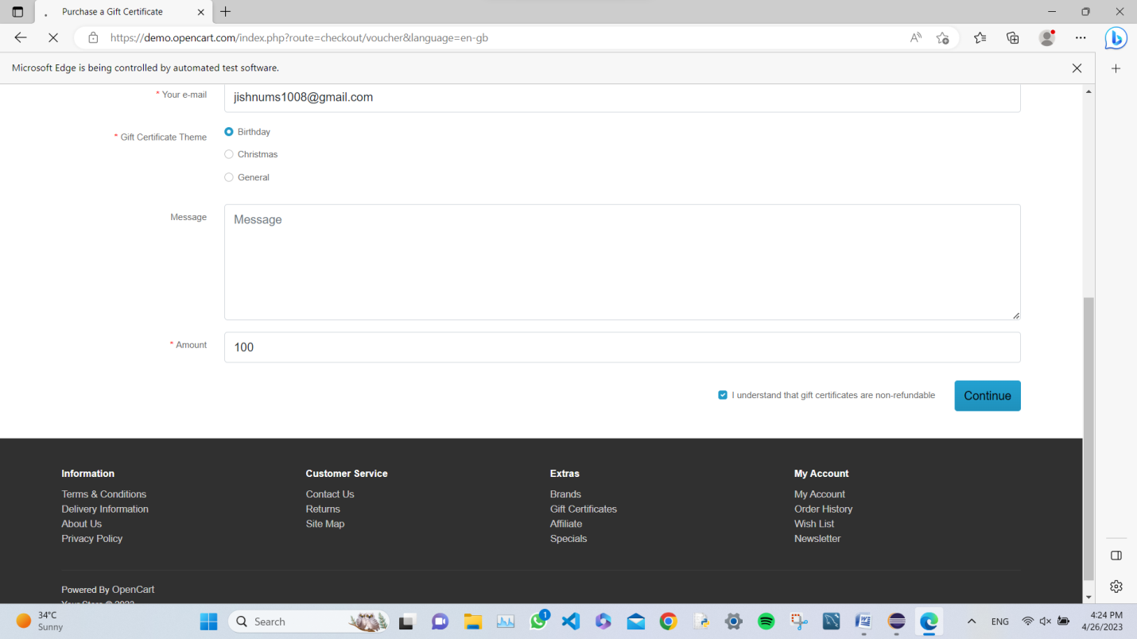

TASK 4:

CODE:

package day4;

import org.openqa.selenium.By;

import org.openqa.selenium.WebDriver;

import org.openqa.selenium.edge.EdgeDriver;

import org.openqa.selenium.edge.EdgeOptions;

import io.github.bonigarcia.wdm.WebDriverManager;

public class task4 {

public static void main(String[] args) {

WebDriverManager.edgedriver().setup();

EdgeOptions con = new EdgeOptions();

con.addArguments("--remote-allow-origins=*");

WebDriver driver = new EdgeDriver(con);

driver.get("https://j2store.net/free/");

driver.manage().window().maximize();

driver.findElement(By.xpath("//*[@id=\'Mod104\']/div/div/div/div/div/div/a")).click();

driver.navigate().back();

driver.navigate().forward();

driver.navigate().refresh();

driver.close();

}

}

OUTPUT:

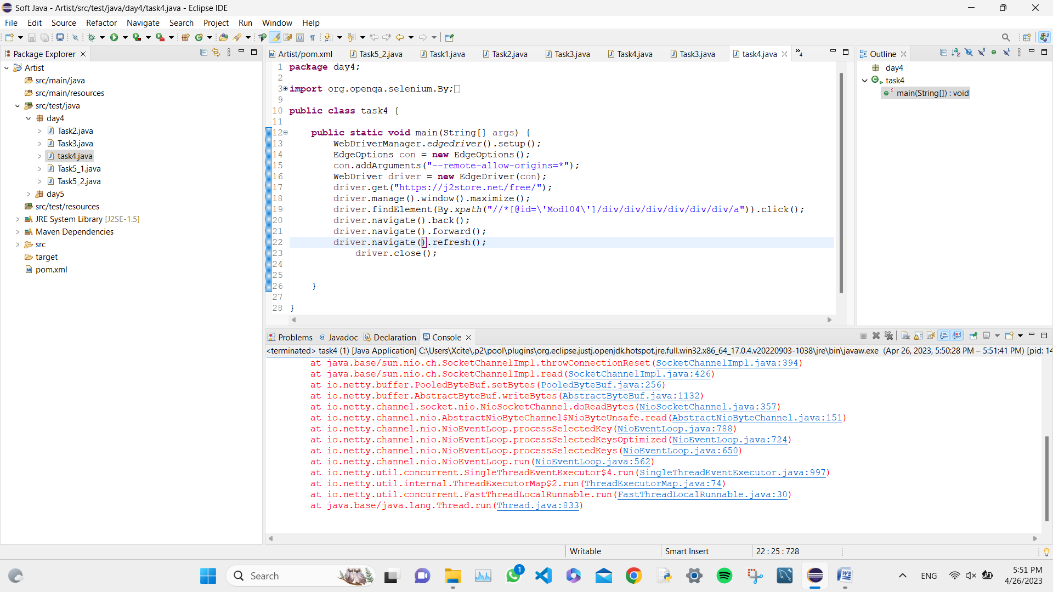

TASK 5.1:

CODE:

package day4;

import org.openqa.selenium.edge.EdgeOptions;

import org.openqa.selenium.edge.*;

import org.openqa.selenium.*;

import io.github.bonigarcia.wdm.WebDriverManager;

public class Task5_1 {

public static void main(String[] args) {

WebDriverManager.edgedriver().setup();

EdgeOptions con = new EdgeOptions();

con.addArguments("--remote-allow-origins=*");

WebDriver driver = new EdgeDriver(con);

driver.manage().window().maximize();

driver.get("https://j2store.net/free/");

String x = driver.getCurrentUrl();

if(x.equals("https://j2store.net/free/"))

System.out.println("Links are equal1");

else

System.out.println("Links are not equal1");

driver.findElement(By.xpath("//*[@id=\'Mod104\']/div/div/div/div/div/div/a")).click();

String y = driver.getCurrentUrl();

if(y.equals("https://j2store.net/free/index.php/shop"))

System.out.println("Links are equal2");

else

System.out.println("Links are not equal2");

}

}

OUTPUT:

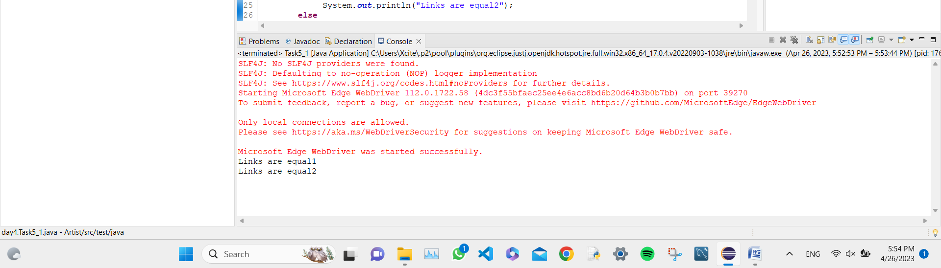

TASK 5.2:

CODE:

package day4;

import java.util.List;

import org.openqa.selenium.By;

import org.openqa.selenium.WebDriver;

import org.openqa.selenium.WebElement;

import org.openqa.selenium.edge.EdgeDriver;

import org.openqa.selenium.edge.EdgeOptions;

import org.openqa.selenium.JavascriptExecutor;

import io.github.bonigarcia.wdm.WebDriverManager;

public class Task5_2 {

public static void main(String[] args) {

WebDriverManager.edgedriver().setup();

EdgeOptions com = new EdgeOptions();

com.addArguments("--remote-allow-origins=*");

WebDriver driver = new EdgeDriver(com);

driver.manage().window().maximize();

driver.get("https://j2store.net/free/");

JavascriptExecutor js = (JavascriptExecutor) driver;

js.executeScript("window.scroll(0,700)","");

driver.findElement(By.xpath("//*[@id=\'Mod112\']/div/div/ul/li[1]/a/img")).click();

List<WebElement> arr = driver.findElements(By.className("product-title"));

for(WebElement i:arr)

System.out.println(i.getText());

}

}

OUTPUT:

